**NAME: DIYA**

**SAP ID:500107068**

**BATCH :2(N-H)**

**EXPERIMENT 2**

**AIM: Working with Docker (Basic Commands)**

**Steps to Complete:**

1. Search a Redis image on DockerHub

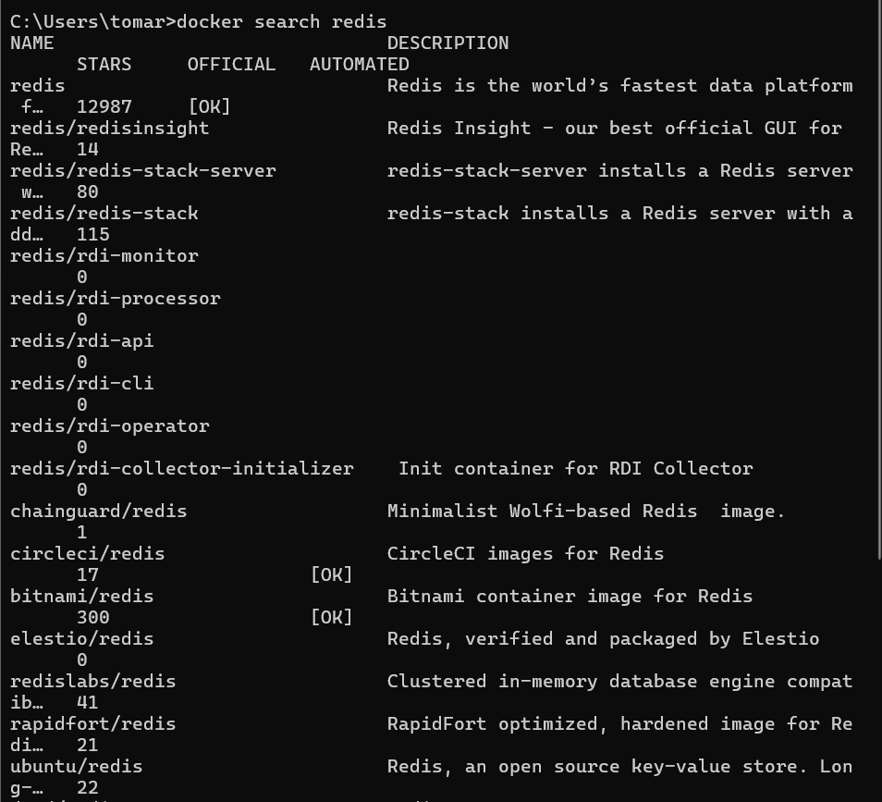

1. Run Docker Container of Redis Image in background

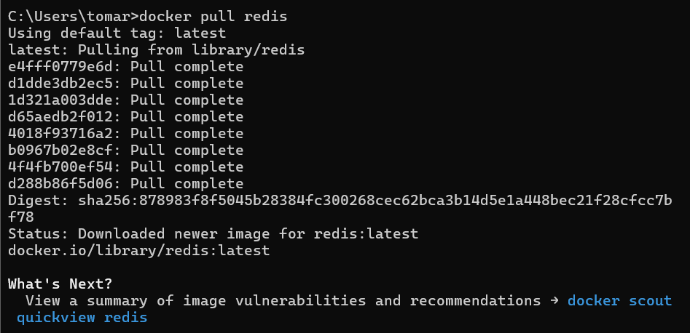



1. Run Docker PS and Docker PS –a

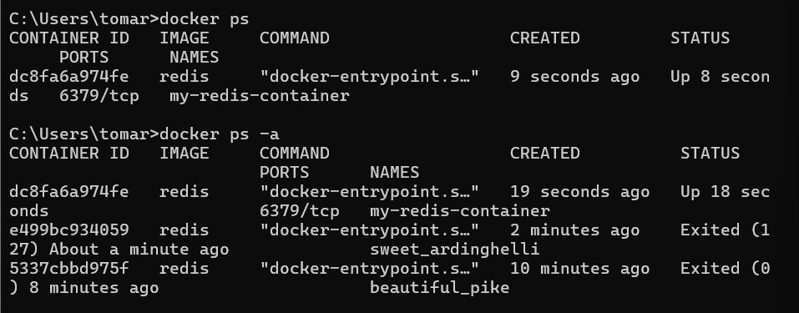

1. Run Docker Container and take its console

